***Khloe Mota***  ***2025/03/05***

***MYP Year 5 Digital Design Brief***

***Grade***:10th

***Project title***: Making a Personal Website using CSS and Html.

***Unit Topic***: Web design and Personal branding

***Criterion A***

Inquiring and Analyzing:

•Examples of personal websites

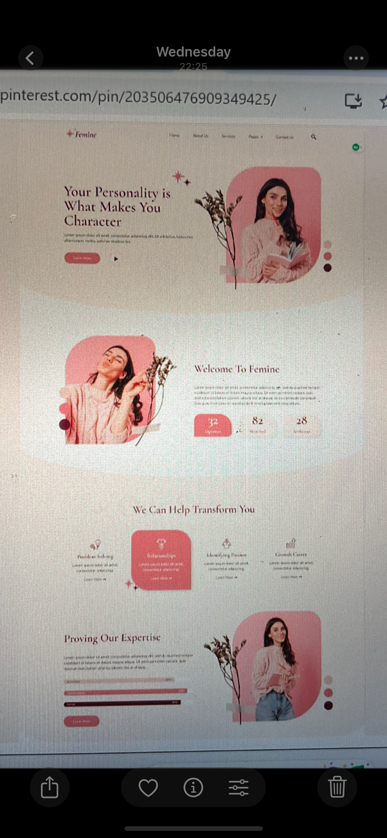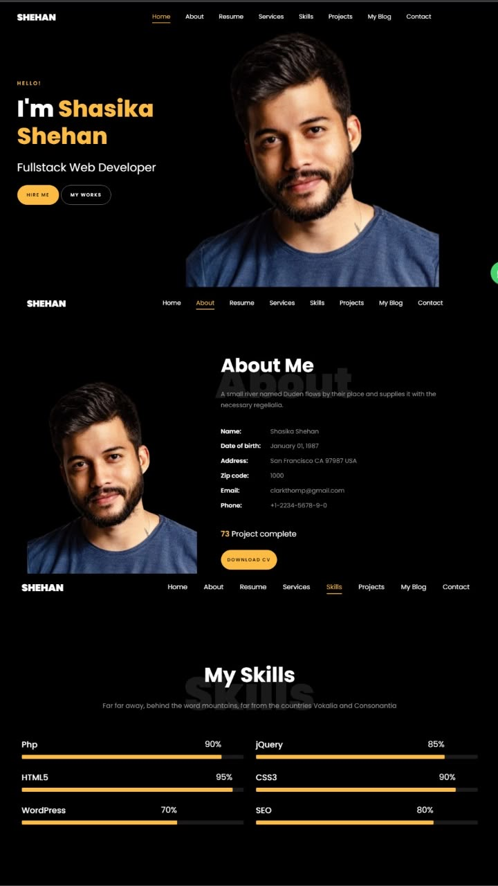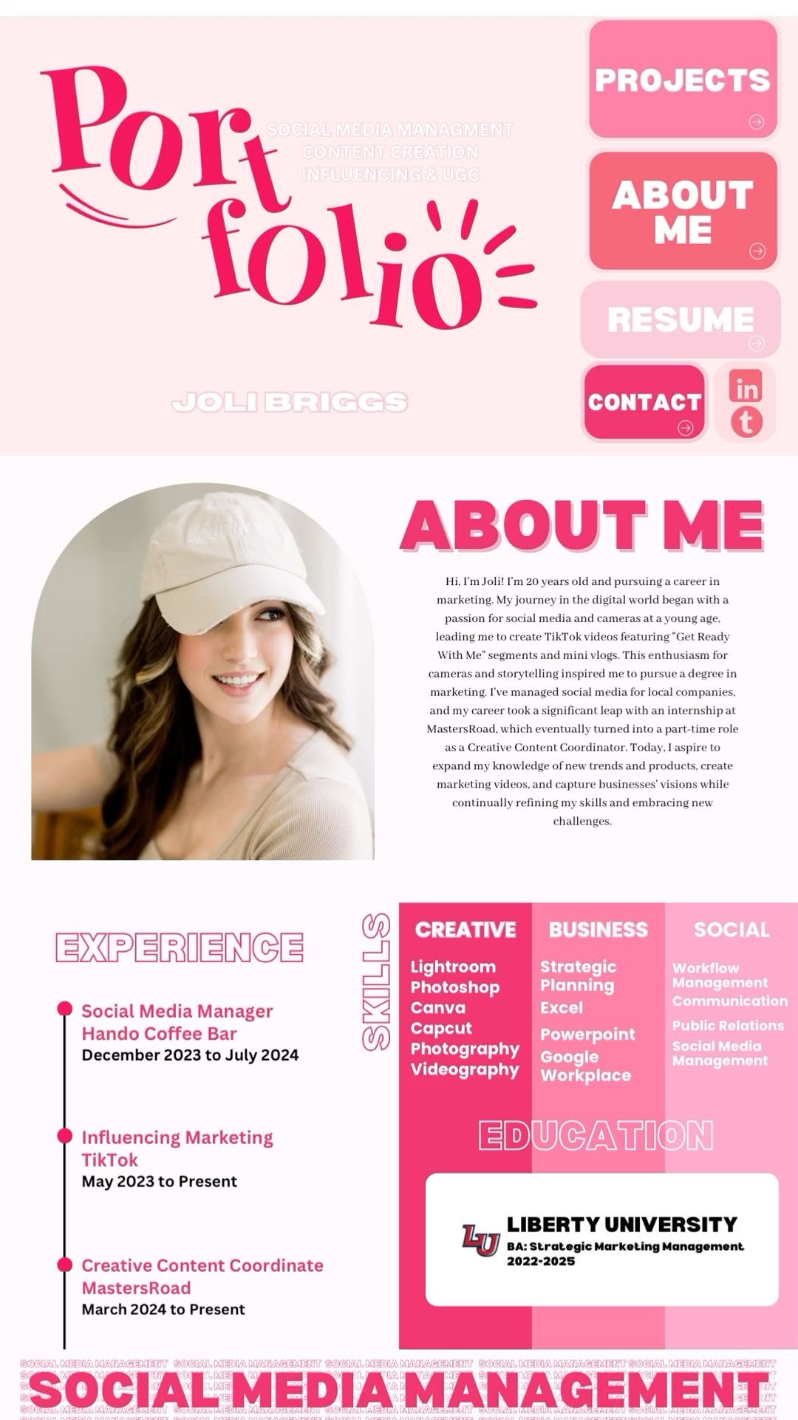

**Effective website principles:**

•To ensure that a website is effective and user friendly,it needs to be visually appealing,easy to use (functionality),and the information needs to be understandable.

Here are some key principles of an effective website:

Visual Hierarchy

Arrange elements (text, images, buttons) to guide users’ attention.

Use size, color, contrast, and whitespace to emphasize important content.

Simplicity

Keep the design clean and avoid clutter.

Use a limited color palette and consistent fonts.

Navigation

Ensure menus and links are intuitive and easy to find.

Use clear labels and logical page structures.

Responsiveness

Design sites that adapt to different screen sizes (mobile, tablet, desktop).

Use flexible grids and media queries in CSS.

Accessibility

Ensure content is readable and usable for people with disabilities.

Use alt text for images and proper HTML semantics.

Consistency

Maintain a uniform style across pages (colors, fonts, button styles).Use a style CSS framework.

**How HTML and CSS work together**

HTML (hyper text markup language): Gives structure to a webpage by defining elements like paragraphs, images,headings and links.

CSS(cascading style sheets):Controls the appearance and layout of html elements. So css styles for color , fonts spacing,animations,and responsive design.

And when both HTML and CSS together coders can create well-designed websites with excellent functionality and structure.

**Audience**

My audiences are my teachers (design and technology), my classmates and and future employers/collages.

My computer teachers need to see whether I now how to apply css to html. They will assess my web development skills, coding structure, and design principles.

For my classmates-They may use your site for inspiration, learning, or collaboration.

For my future employers and colleagues-Thy may use it ,to not only see my skill sets but also my hobbies and goals.

**Research**

Primary information: Portfolio websites are known as digital platforms that’s an individual’s use to show there skillset, achievements, and experiences. Primary information on portfolio websites includes: An about section, showcase of work(gallery), contact information, feedback / reviews of clients.

primary Information on Portfolio Websites:  
1. About Section:  
• A brief introduction of the individual or organization.  
• Details about their expertise, background, and mission.  
2. Showcase of Work:  
• High-quality images, videos, or descriptions of past projects.  
• Clear categorization for easy navigation (e.g., photography, web design, writing).  
3. Skills and Expertise:  
• A list or description of core competencies, tools, and technologies used.  
• Certifications or qualifications, if relevant.  
4. Contact Information:  
• Email, phone number, or a contact form.  
• Links to social media profiles or professional networks (e.g., LinkedIn).  
5. Testimonials or Client Reviews:  
• Feedback from previous clients or collaborators.  
6. Achievements:  
• Awards, recognitions, or milestones achieved.  
  
Secondary information refers to data tmhat has been interpreted, analysed, or processed from primary sources.  
  
Secondary Information on Portfolio Websites refers to the additional content that helps provide context, background, or insights into a persons work and experiences. This type of information is derived from analysis and enhances the overall narrative of the portfolio, supporting primary information.  
  
Examples of Secondary Information on Portfolio Websites:  
  
1. Case Studies:  
• Detailed analyses of specific projects, including challenges, solutions, and results. While primary information focuses on the raw work, case studies offer insights into the thought process, strategies, and decisions that led to the outcome.  
  
Purpose of Secondary Information on Portfolio Websites:  
  
1. Provide Context: It adds depth to the primary content by explaining the “why” behind the work and giving a broader perspective.  
2. Build Credibility: External validation through testimonials, media mentions, or awards reinforces the creator’s trustworthiness and expertise.  
3. Demonstrate Industry Knowledge: Blog posts, articles, or case studies show that the creator is engaged with current trends, challenges, and solutions in their field.  
4. Enhance Persuasion: By showing that others recognize or value the creator’s work, secondary information helps persuade potential clients, employers, or collaborators of the creator’s capabilities.  
  
To concise, secondary information is portfolio website supports and enriches the primary work displayed, adding and deeper understanding of the creator’s abilities and reputation.

**Purpose of my website**

The purpose of this website is to showcase my skills as a web designer,in HTML and CSS . Also acting as a real portfolio,and will help me develop skills for when I actually need to make a portfolio.

***Criterion B***

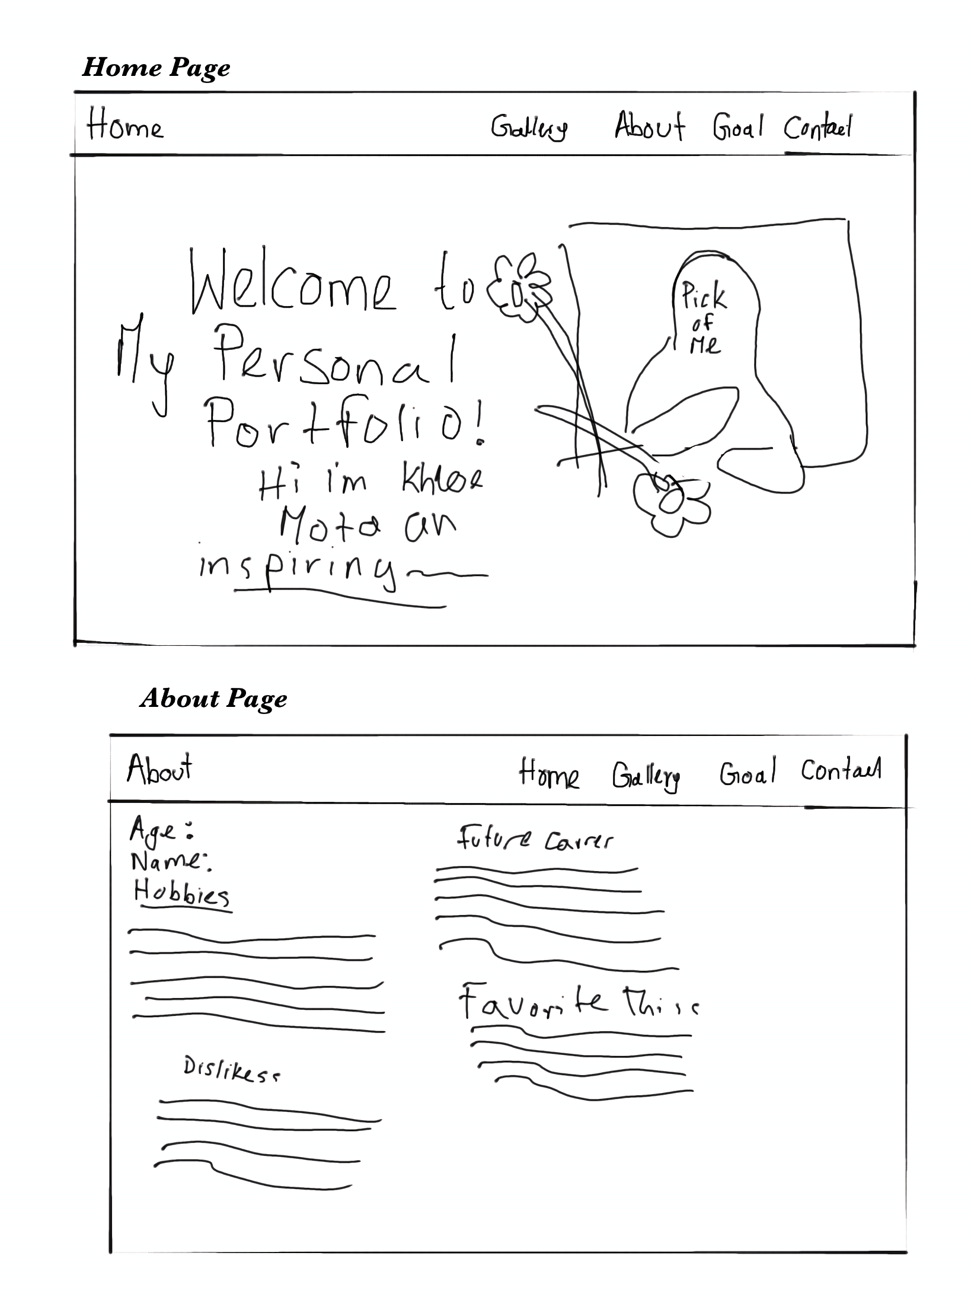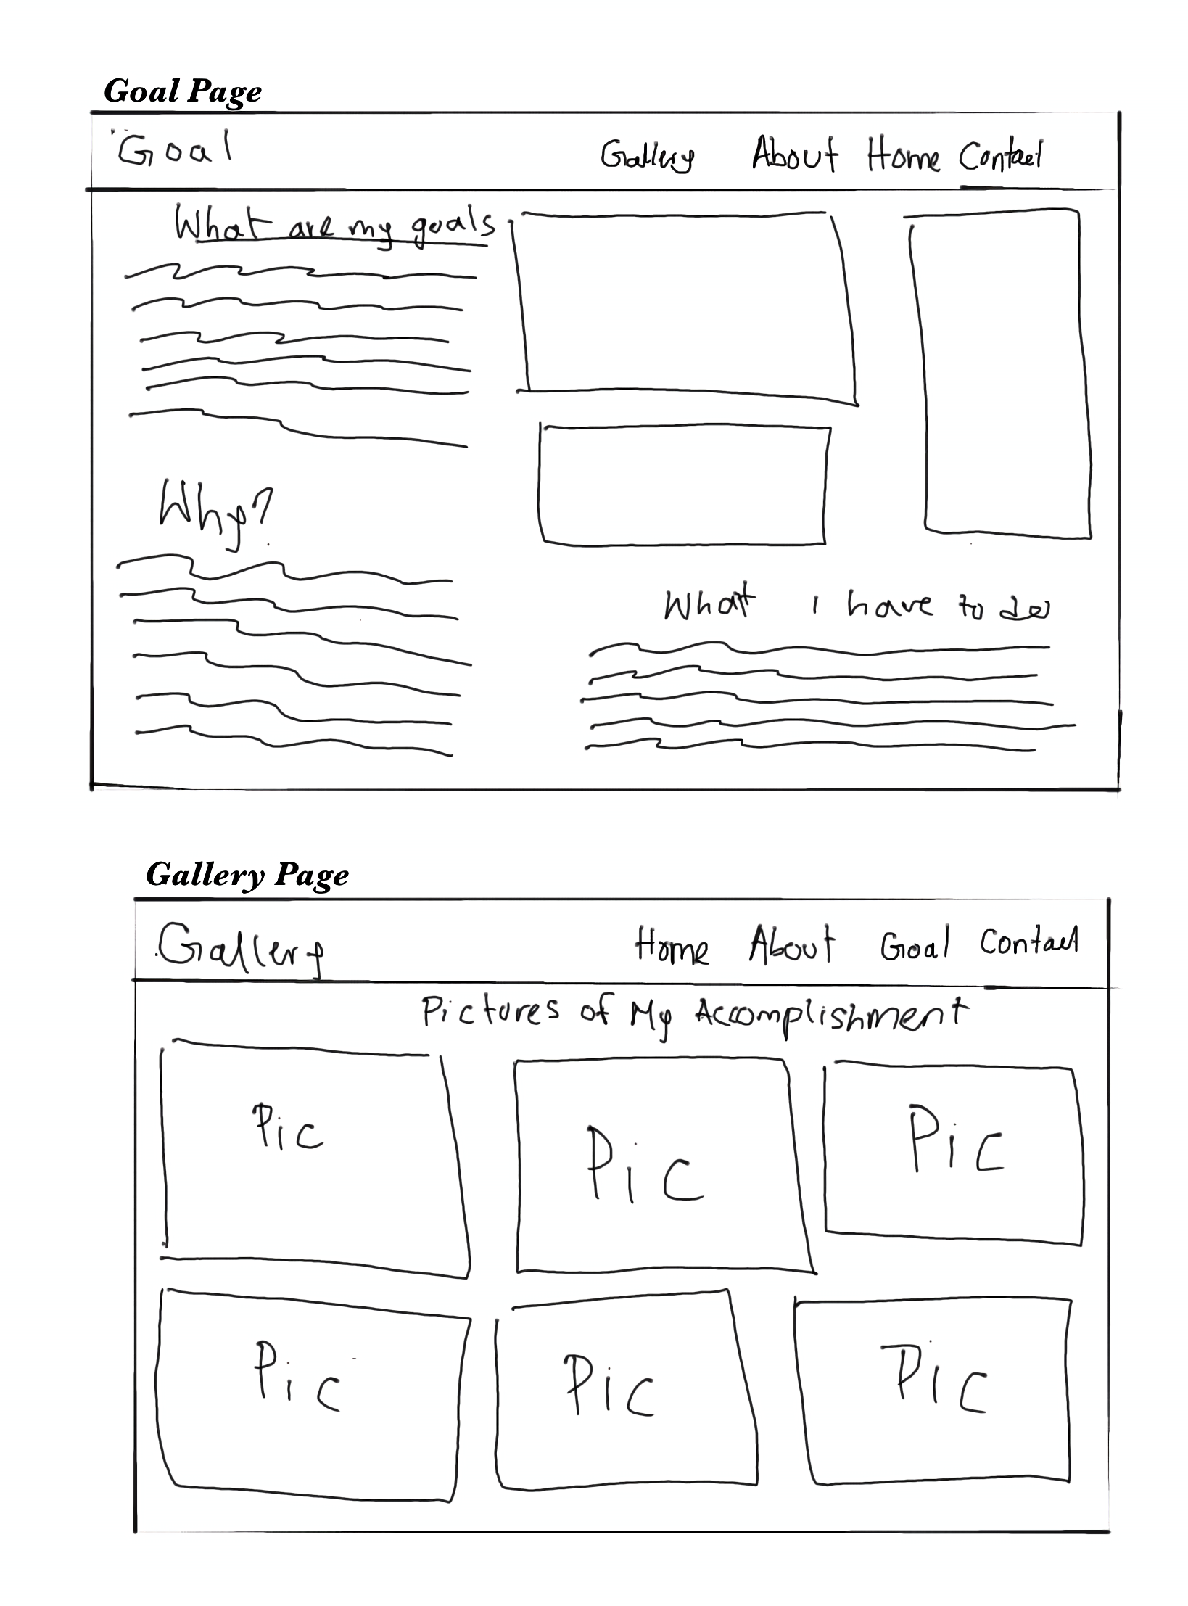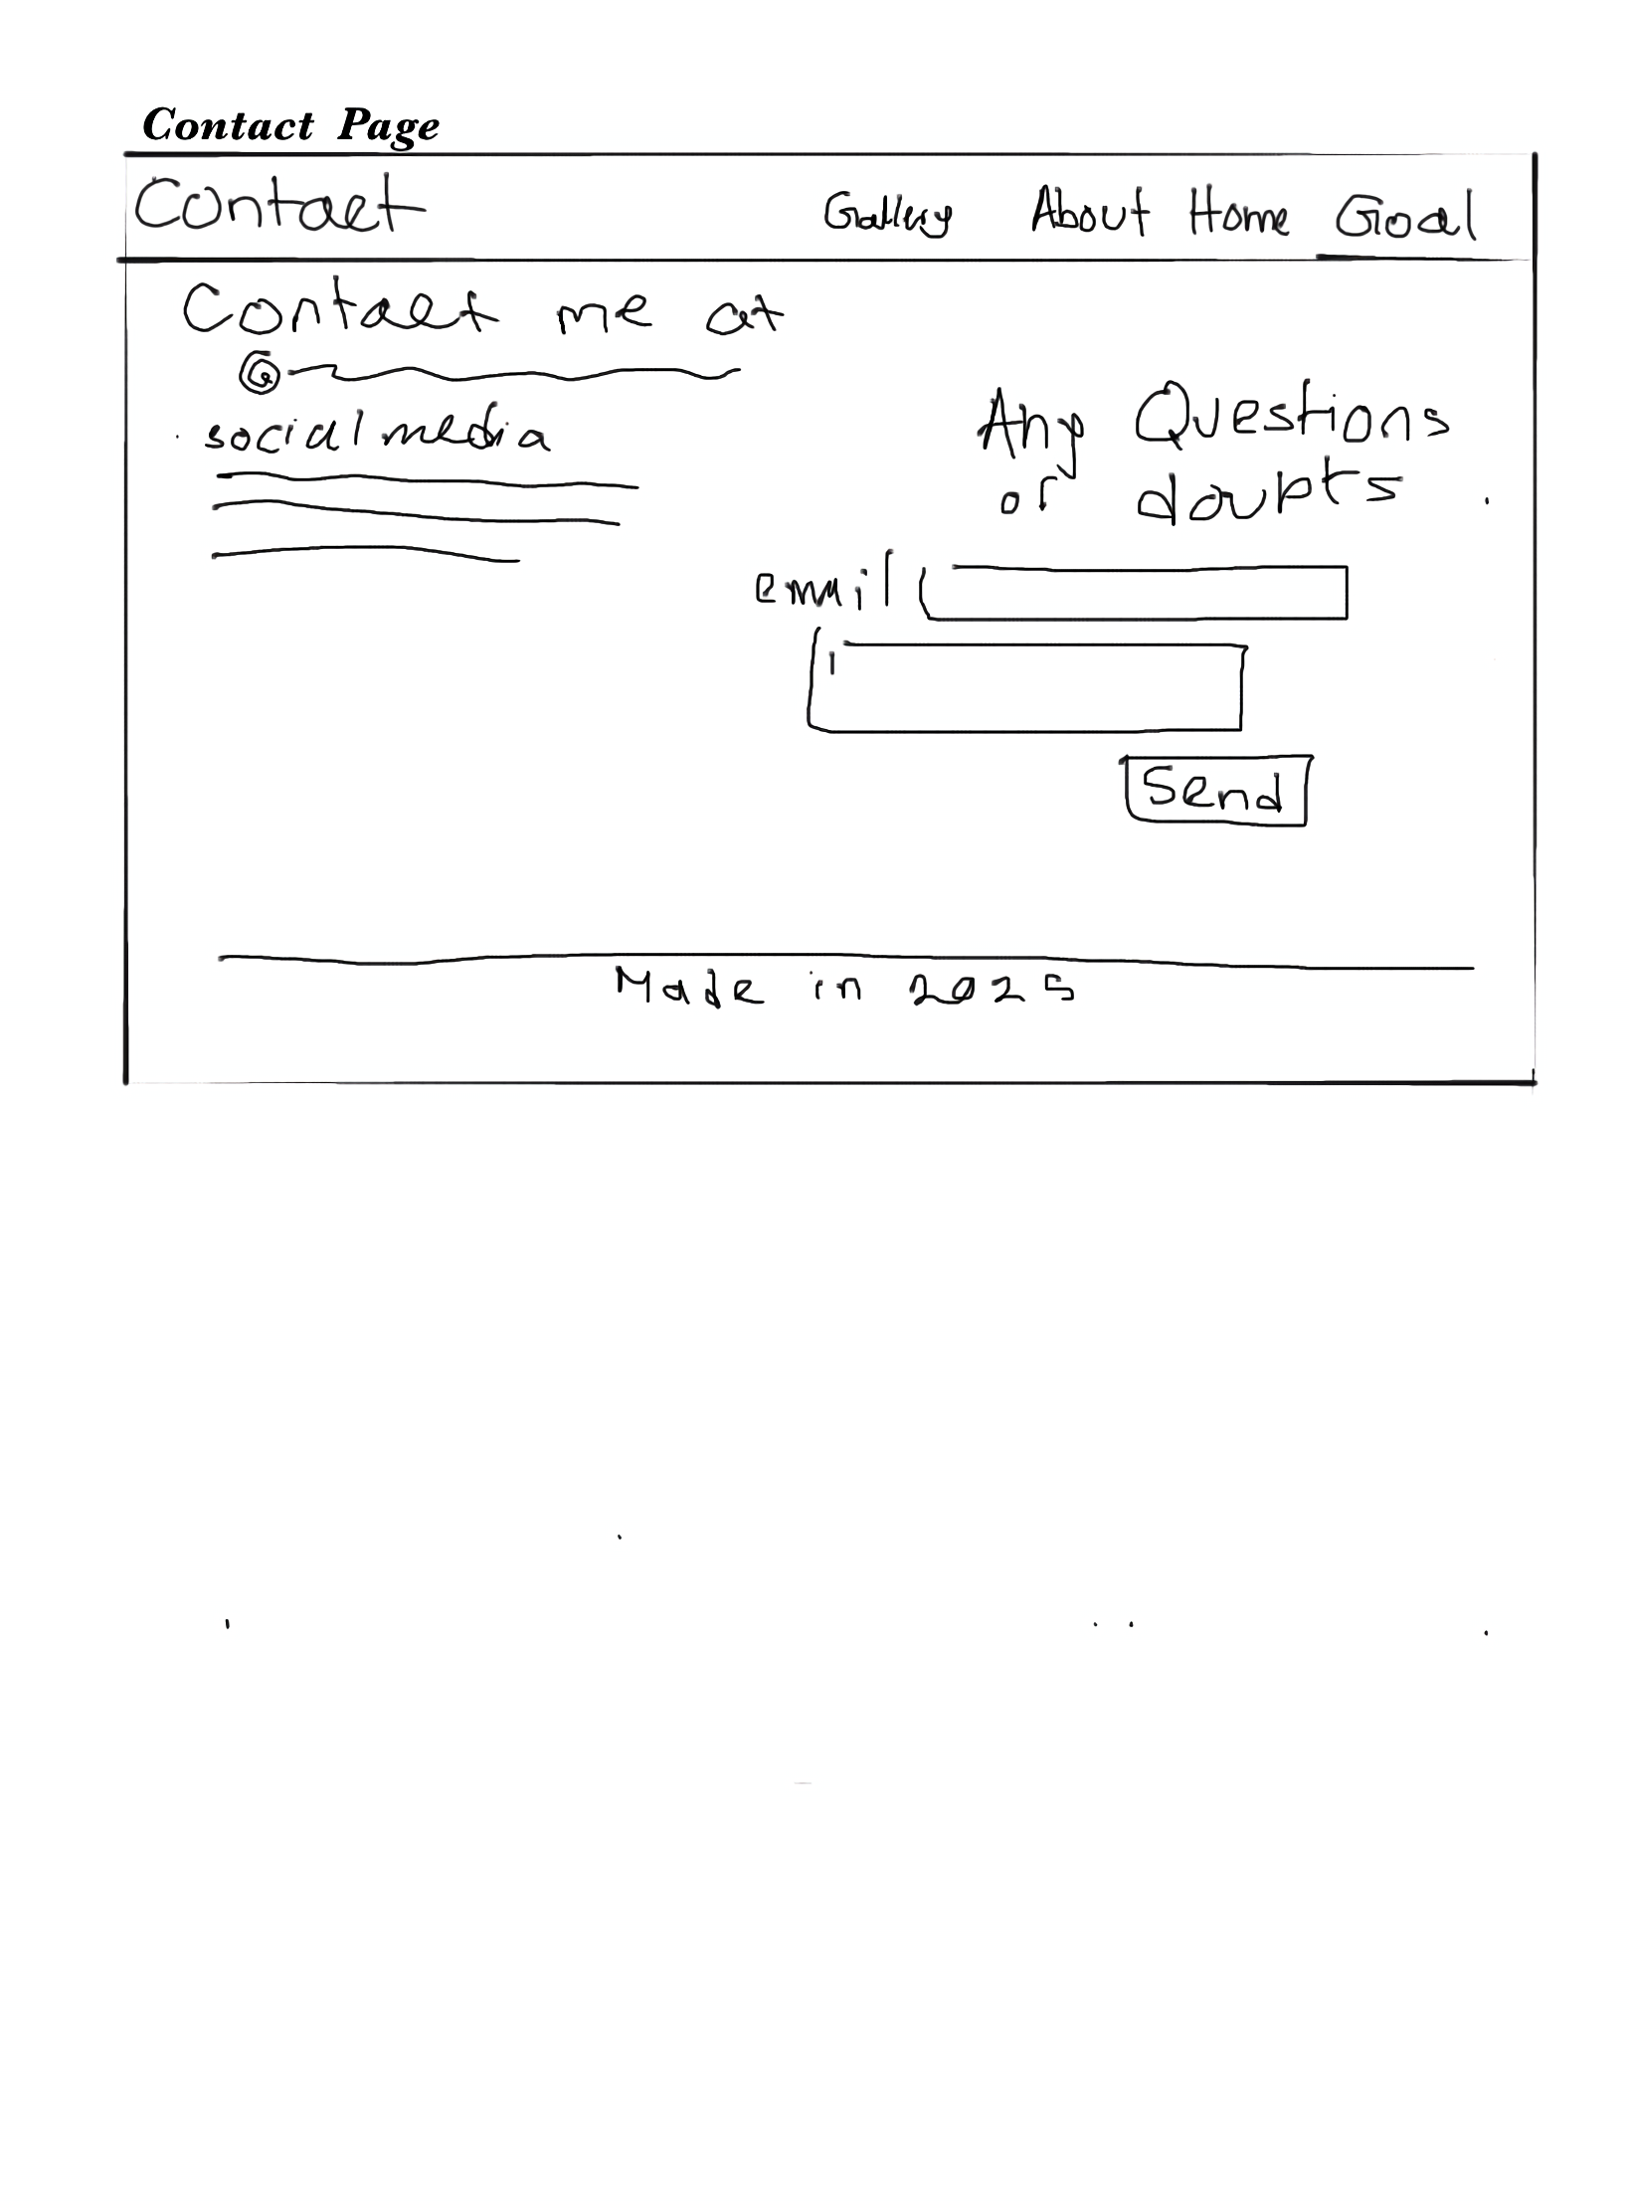

**Color theme:-**

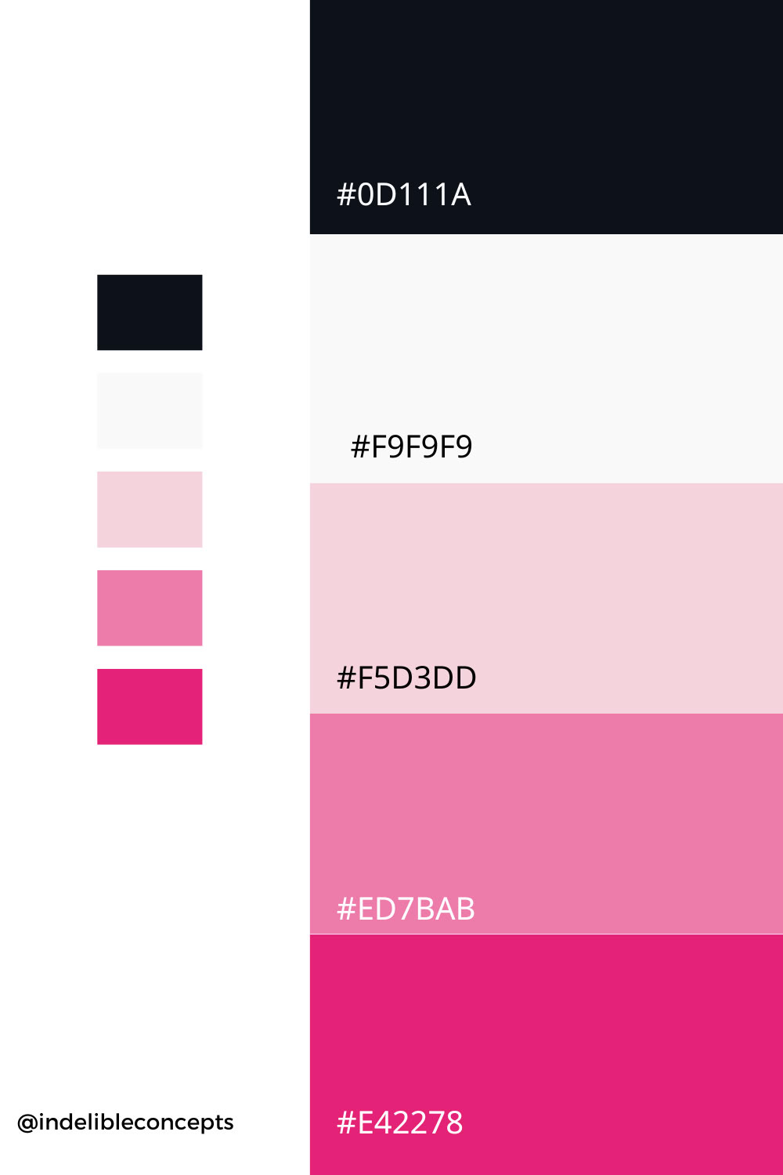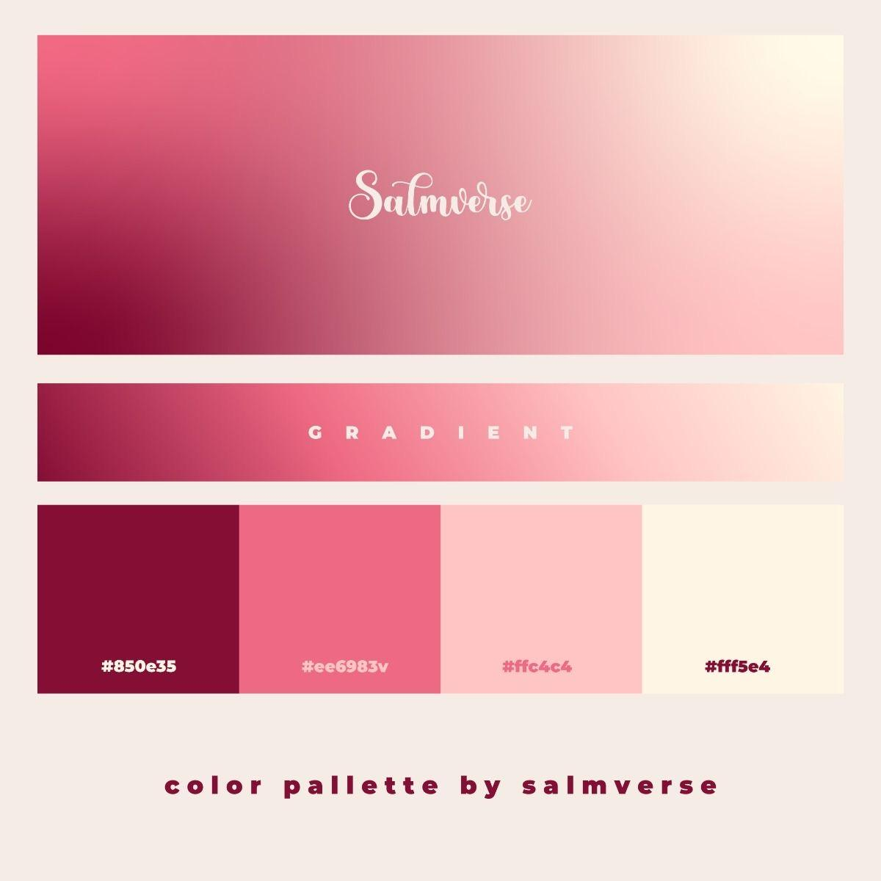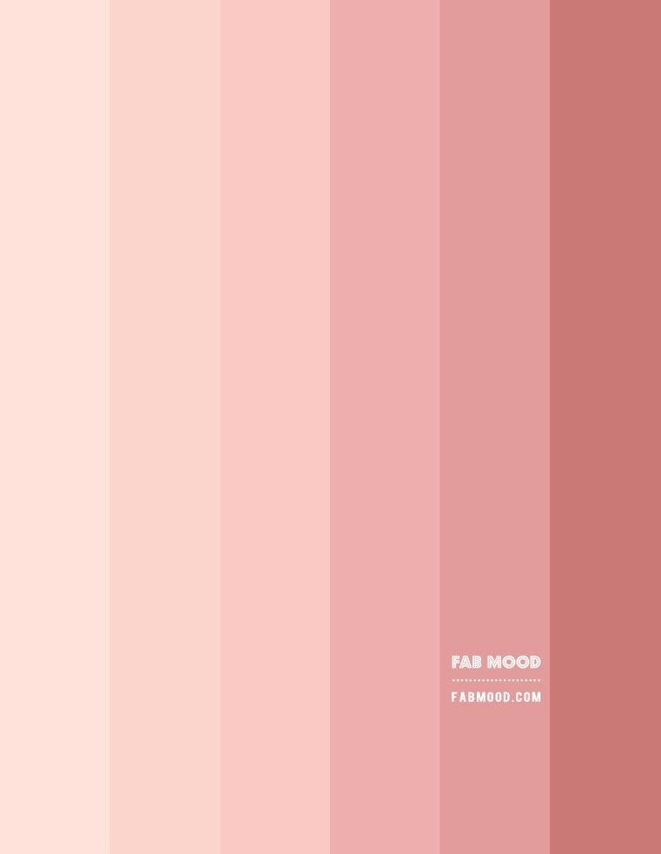

Reasoning : The color palette I’m using for my portfolio,is mostly white, red and pink,because white , pink, and red create a balanced and meaningful combination. White symbolizes purity and neutrality, pink adds warmth and softness, and red brings passion and intensity. Together, they blend harmoniously, with white softening red’s boldness and pink providing a smooth transition.White, pink, and red create a visually appealing and engaging color scheme for a website. That’s why it’s my color palette.

***Criterion C***

When making my home page, putting the two flowers was my biggest problem . But because of time I decided to remove the flowers and just use a normal background.

Honestly I’m not too happy with the results , I wish I did better.

***CRITERION D***

Feedback from classmate:

Juliana: There's too much space between the pages on the navbar.

Hannah : I like the floral theme, but it feels a bit childish.

Mary : I love the goal ,page and how you talk about medicine as your passion.

Linda :The website is easy to navigate . But the layout is not attractive

Before

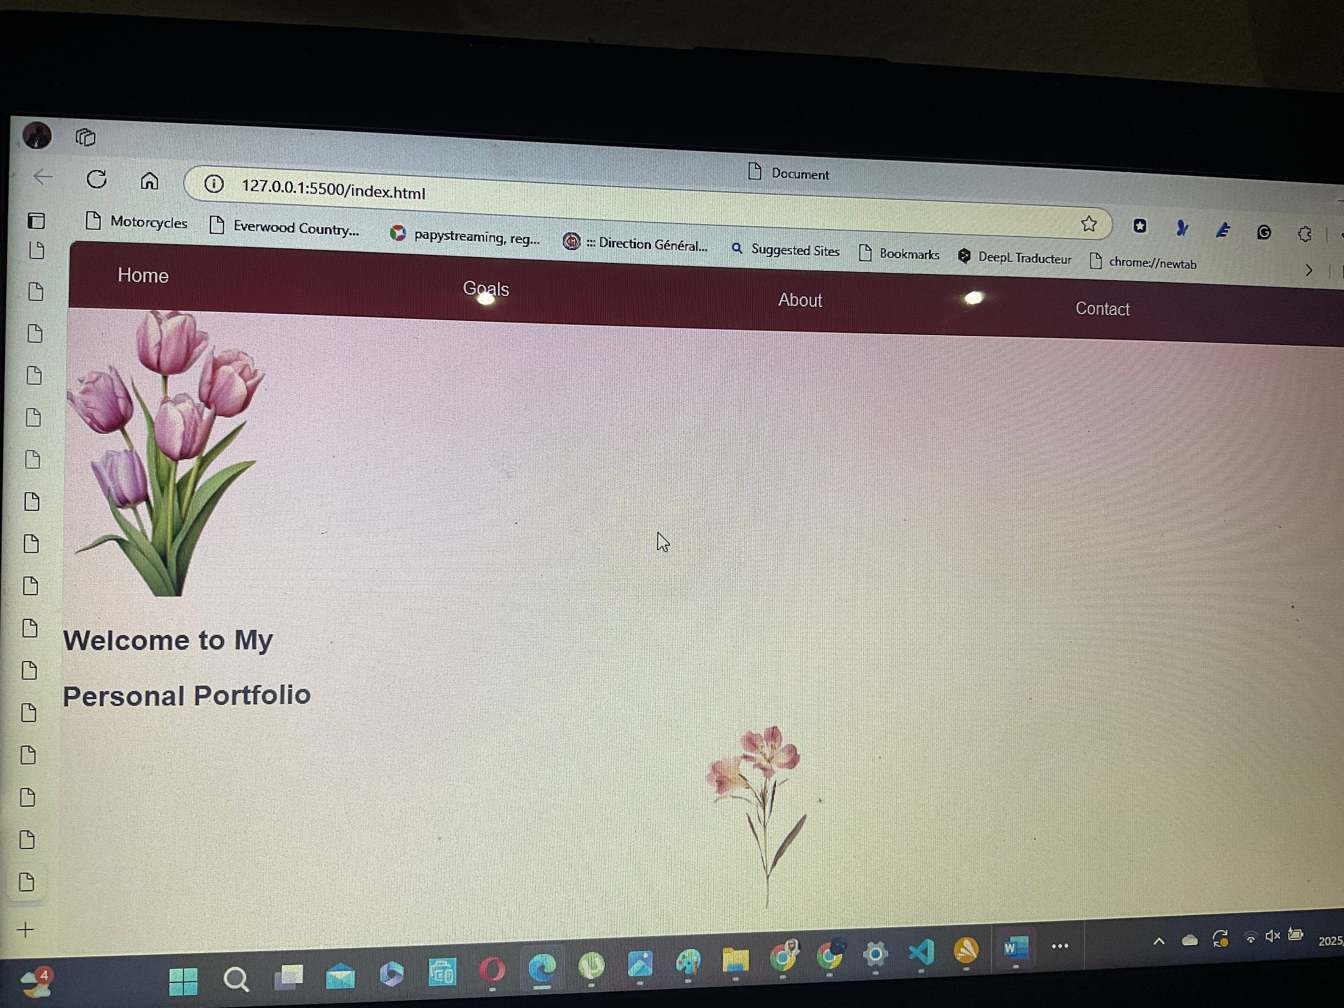

2-second try

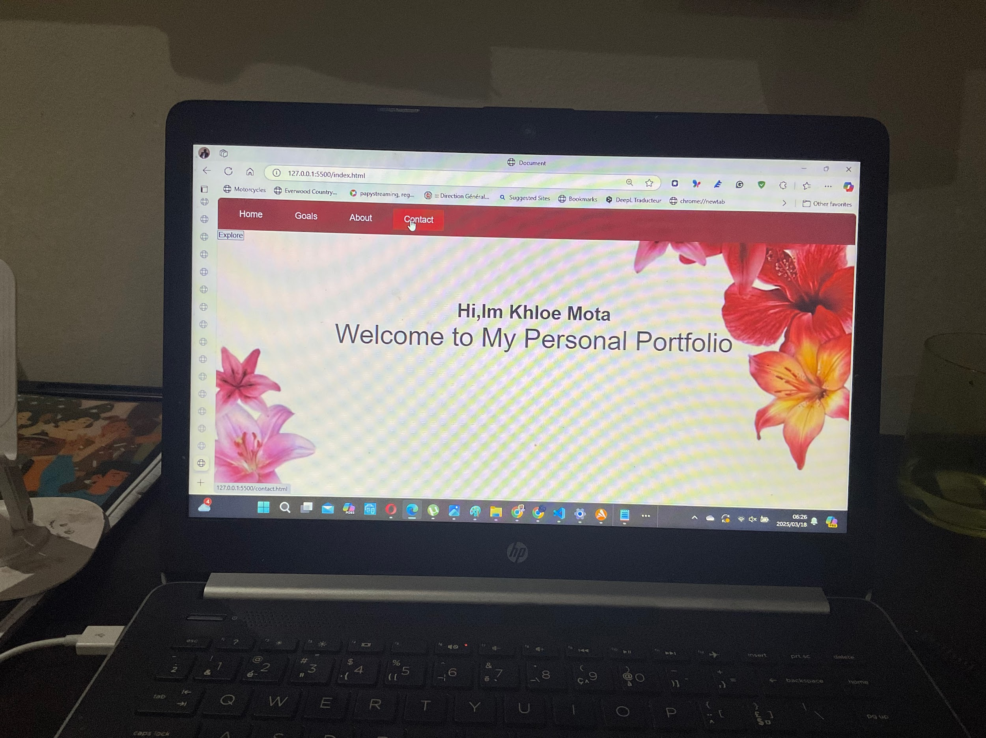

3rd try